Documentum Installation Guide

- Download Helm Chart
  - Open PowerShell
  - Add the classic Helm repo
    - Command:
helm repo add opentext https://registry.opentext.com/helm `
--username dipyaman.kundu@woodside.com `
--password '******'
  - Update repo
    - Command:
helm repo update
  - Pull the chart
    - Comamnd:
helm pull opentext/documentum --version 25.4.7 –untar
or
helm pull opentext/documentum --version 25.4.7

- Software Required for Jump Server Installed (Infra Team)
Software Name | Version | Description
Azure CLI | 2.88.0 | Microsoft MSI
kubectl | v1.30.0 | az aks install-cli → dl.k8s.io
Helm | v3.16.2 | github.com/helm/helm/releases
nginx |  | registry.k8s.io/ingress-nginx/controller → az acr import → ACR
nginx helm chart |  | kubernetes.github.io/ingress-nginx (helm pull) – GitHub
aks cluster | 1.34.8 | Microsoft Azure
postgres | 16.14 | Docker Hub → ACR
Notepad++ | Latest version
Postman | Latest version
VS Code | Latest Version

- ACR Details:
Environment | ACR Name | Server Details
Dev | acrdctmiodevscus001 | acrdctmiodevscus001.azurecr.io
Test | acrdctmintnpscus001 | acrdctmintnpscus001.azurecr.io
Prod

- Before using any command in powershell, needs to run below commands:
  - az login --identity
  - az account set --subscription ceda2744-a50d-4918-b05d-b97a68cf3ab0
  - For non-prod: az aks get-credentials --resource-group rg-dctmio-np-scus-001 --name aks-dctmint-np-scus-001 --admin --overwrite-existing
  - For non-prod: kubectl config use-context aks-dctmint-np-scus-001-admin

- Pull the images to Azure ACR
  - OpenPowershell as Administrator
    - Command:
az acr import `
--name acrdctmintnpscus001 `
--source registry.opentext.com/ot-dctm-rest:25.4 `
--image documentum/ot-dctm-rest:25.4 `
--username "dipyaman.kundu@woodside.com" `
--password "Kolkata9800@"

- Show tags:
  - Open
    - Command:
az acr repository show-tags `
--name acrdctmintnpscus001 `
--repository documentum/ot-dctm-rest `
-o table
- Helm Chart Modification Details:
  - Content Server:
    - Need to check
  - OTDS:
    - configuration.yml
      - otds.global.namespace: dctm-nonprod
      - otds.global.database.adminDatabase: postgres
      - otds.global.database.adminUsername: otdsadmin
      - otds.otdsws.adminEmail: dipyaman.kundu@woodside.com
      - otds.otdsws.otdsdb.url: jdbc:postgresql://psql-dctmint-np-scus-001.postgres.database.azure.com:5432/otdsdb?sslmode=require
- Helm Install:
helm install dctmglobal . --values .\config\configuration.yml --values .\config\constants.yaml --values .\config\passwords_k8api.yaml --values .\platforms\azure.yaml --values .\dockerimages-values.yaml --values documentum-resources-values-medium.yaml --values .\documentum-components.yaml --values .\values.yaml -n dctm-nonprod

- Helm Upgrade:
helm upgrade dctmglobal . --values .\config\configuration.yml --values .\config\constants.yaml --values .\config\passwords_k8api.yaml --values .\platforms\azure.yaml --values .\dockerimages-values.yaml --values documentum-resources-values-medium.yaml --values .\documentum-components.yaml --values .\values.yaml -n dctm-nonprod

- Go inside a pod:
kubectl exec -it dcc-0 -c dcc -n dctm-dev – bash

- Database Info for Dev:
  - PostgreSQL Hostname: psql-dctmio-dev-scus-001.postgres.database.azure.com
  - Port: 5432
  - SSL Mode: required (sslmode=require)
  - PostgreSQL Admin Account
Account | Username | Password | Purpose
PostgreSQL Admin | dctmadmin | Dctm7Admin9Woodside4Kv2 | Database administration, role creation

  - Content Server Databases (Individual Credentials)
Database | Database Owner Role | Password | Notes
dctm_io_global | dctm_io_global_owner | IoGlobalDctm7Wde2026 | Primary docbase for DEV
dctm_shenzi | dctm_shenzi_owner | ShenziDctm7Wde2026Kx | Secondary docbase
dctm_sangomar | dctm_sangomar_owner | SangomarDctm7Wde2026 | Secondary docbase
dctm_lalng | dctm_lalng_owner | LalngDctm7Wde2026Kx | Secondary docbase
dctm_bna | dctm_bna_owner | BnaDctm7Woodside2026 | Secondary docbase
dctm_trion | dctm_trion_owner | TrionDctm7Wde2026Kx | Secondary docbase

  - OTDS Database
Database Name | Username | Password | Notes
otdsdb | dctmadmin | Dctm7Admin9Woodside4Kv2 | OTDS identity broker database

- Database Info for Non-Prod

  - PostgreSQL Hostname: psql-dctmint-np-scus-001.postgres.database.azure.com
  - Port: 5432
  - SSL Mode: required (sslmode=require)
  - PostgreSQL Admin Account
Account | Username | Password | Purpose
PostgreSQL Admin | dctmadmin | Dctm7Admin9Woodside4Kv2 | Database administration, user/role creation
PostgreSQL Admin | postgres | Dctm7Admin9Woodside4Kv2_ | Database administration, user/role creation- In use in Helm chart

  - Content Server Databases (Individual Credentials)
Database | Database Owner Role | Password
GLOBAL | dctm_owner | DctmOwner2026
SHENZI | dctm_owner | DctmOwner2026
SANGOMAR | dctm_owner | DctmOwner2026
LALNG | dctm_owner | DctmOwner2026
BNA | dctm_owner | DctmOwner2026
TRION | dctm_owner | DctmOwner2026

  - OTDS Database
Database Name | Username | Password | Notes
otdsdb | otdsdb_user | Dctm7Admin9Woodside4Kv2_ | OpenText Identity Services database

- Database Setup in azure Postgres:
  - Content server DB (Postgres) Pre-requisites:

    - Create a database user in postgres
    - Create database inside the pre-defined tablespace with above created database user as the owner. The format to be followed for the database name is database name = dm_<docbasename>_docbase
    - Grant all privileges on database-to-database user(ref from step a).
    - Connect to database and grant all on schema public to docbase owner.
    - Connect to the dm_<docbasename>_docbase with <docbaseOwner>
    - GRANT ALL ON SCHEMA public TO "<docbaseOwner>";
    - CREATE SCHEMA "<docbasename>" AUTHORIZATION "<docbaseOwner>";
    - SET search_path TO "<docbasename>";
    - GRANT ALL ON SCHEMA "<docbasename>" TO "<docbaseOwner>";

  - OTDS DB (postgres) Pre-requisites:

    - Create a DB user account with name “otdsdb_user”
    - Create OTDS DB as “otdsdb” and set owner as “otdsdb_user”

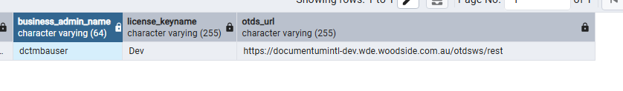

- Image List:
Image Name | Available Tag(s)
documentum/ot-dctm-admin | 25.4.7
documentum/ot-dctm-admin-tomcat | 25.4.7
documentum/ot-dctm-bpm-installer | 25.4, 25.4.7
documentum/ot-dctm-client-classic | 25.4
documentum/ot-dctm-client-config | 25.4
documentum/ot-dctm-client-installer | 25.4
documentum/ot-dctm-dsis | 25.4
documentum/ot-dctm-fluentd | 25.4
documentum/ot-dctm-reports-base | 25.4
documentum/ot-dctm-reports-client | 25.4
documentum/ot-dctm-reports-installer | 25.4
documentum/ot-dctm-rest | 25.4
documentum/ot-dctm-server | 25.4.7
documentum/ot-dctm-tomcat | 25.4.7
documentum/ot-dctm-workflow-designer | 25.4
otds-server | 25.4.7
ingress-nginx/controller | v1.15.1
ot-dctm-rest | 25.4
ot-dctm-content-connect | 25.4
ot-dctm-content-connect-dbinit | 25.4
ot-dctm-client-rest | 25.4
ot-dctm-content-fetcher | 25.4
ot-dctm-search-parser | 25.4
dctm-xplore-cps | 22.1.14
dctm-xplore-indexagent | 22.1.14
dctm-xplore-indexserver | 22.1.14

- Documentum Portal URL & Credentials:
Non-Prod:
Portal | URL | Username | Password
DA | https://documentumintl-np.wde.woodside.com.au/da | dmadmin | Ino9@Woodside2026_
D2-Config | https://documentumintl-np.wde.woodside.com.au/D2-Config | dmadmin | Ino9@Woodside2026_
D2 | https://documentumintl-np.wde.woodside.com.au/D2 | dmadmin | Ino9@Woodside2026_
OTDS | https://documentumintl-np.wde.woodside.com.au/otds-admin | otadmin@otds.admin | svcotdsAdminNP@123
Workflow Designer | https://documentumintl-np.wde.woodside.com.au/DocumentumWorkflowDesigner/signin.html | dmadmin | Ino9@Woodside2026_
IndexAgent | http://documentumintl-np.wde.woodside.com.au/IndexAgent/login_dss.jsp | dmadmin | Ino9@Woodside2026_
Content Connect | http://documentumintl-np.wde.woodside.com.au/cc/admin | dmadmin | Ino9@Woodside2026_

In line user: dipya@wsnonsync/Dipyaman@123

kubectl apply -f documentum/config/vault_secret.yaml

- Configuration.yml
Section | Property | Value
otds.global | namespace | dctm-nonprod
otds.otdsws | customSecretName | vault-secret-config
otds.otdsws | publicHostname | documentumintl-np.wde.woodside.com.au
otds.otdsws.otdsdb | url | jdbc:postgresql://psql-dctmint-np-scus-001.postgres.database.azure.com:5432/otdsdb?sslmode=require
content-server.docbase | index | DM_GLOBAL_DOCBASE
content-server.ExtCS | nativeExtPort | 80
content-server.ExtCS | sslExtPort | 81
content-server.otds | cert_jwks_url | https://documentumintl-np.wde.woodside.com.au/otdsws/oauth2/jwks
content-server.extraEnv | GLOBAL_resource_id | ""
content-server.extraEnv | GLOBAL_secretKey | ""
content-server.extraEnv | MIGRATE_LDAP_DOCBASES | GLOBAL
content-server.extraEnv | GLOBAL_MIGRATE_LDAP_CONFIGS | ""
da.otds | url | https://documentumintl-np.wde.woodside.com.au/otdsws
d2config.customConfigurations.filename | filename | GLOBAL:DCTM-Reports-Application-25.4.0-Export-Config.zip

- Values.yaml:
Section | Property | Value
global | rwoStorage | managed-csi
global | rwmStorage | azurefile-nfs-eit
global | docbase | GLOBAL
global | isVaultEnabled | true
global | vaultType | K8API
global | otdsUserName | otdsdb_user
global | ingressUrl | documentumintl-np.wde.woodside.com.au/
global | aekLocation | Remote_Vault
global | ingressProtocol | https
global | ingressDomain | wde.woodside.com.au
global | publicIngressDomain | wde.woodside.com.au
global | vpnIngressDomain | wde.woodside.com.au
global | db_hostname | psql-dctmint-np-scus-001.postgres.database.azure.com
global | db_ssl | true
global | db_ssl_mode | require
global | db_service | "" (empty)

Note: CREATE EXTENSION IF NOT EXISTS pg_trgm SCHEMA pg_catalog; --not allowed

SELECT extname, extnamespace::regnamespace
FROM pg_extension
WHERE extname = 'pg_trgm';

06/10/26:
During the deployment and configuration validation, the following issues were identified:
1. Image Issue - Name Mismatch
A discrepancy was found between the expected image name and the deployed image name, resulting in image validation/deployment failures.
2. Password Complexity Rule Violation
The configured password did not meet the required complexity standards, causing authentication validation to fail.
3. Database Certificate Issue
The Content Server was unable to establish connectivity with the database server due to an SSL/TLS certificate issue. The database certificate could not be validated, resulting in a failure of communication between the Content Server and the database. We have taken the copy from dev env and applied to non prod env.
Note: Need to change the license for prod.
4. We have 3 pods for content server, initally 3rd pod was not coming up. So, from Infra side, increased user pod count, after that 3rd pod came up.

07/10/2026:
During the deployment and configuration validation, the following issues were identified:
1. OTDS pod deployemnt failed with db user error -> db user creadentails correctly placed -> fixed

2. DA pod issue with PVC reference -> PVC will be created as part of d2 deployument
3. D2 deployment -> helm chart updates
d2 config + d2 classic: (component.yaml)
dtrbase
peinstaller
dctmclientinstaller

4. Pod deployemnt failed for the above components due to images not available in ACR
- Downloaded the images as required

5. Content server issue: [CS PE Installer] Error occured while updating the PE configuration in CS DfException:: THREAD: main; MSG: [DM_QUERY_E_NOT_GROUP]error: "ALTER or DROP GROUP: The group specified (documentum_workflow_designer) does not exist."; ERRORCODE: 100; NEXT: null
DfException:: THREAD: main; MSG: [DM_QUERY_E_NOT_GROUP]error: "ALTER or DROP GROUP: The group specified (documentum_workflow_designer) does not exist."; ERRORCODE: 100; NEXT: null
at com.documentum.fc.client.impl.docbase.DocbaseExceptionMapper.newException(DocbaseExceptionMapper.java:57)
at com.documentum.fc.client.impl.connection.docbase.MessageEntry.getException(MessageEntry.java:39)
at com.documentum.fc.client.impl.connection.docbase.DocbaseMessageManager.getException(DocbaseMessageManager.java:137)
at com.documentum.fc.client.impl.connection.docbase.netwise.NetwiseDocbaseRpcClient.checkForMessages(NetwiseDocbaseRpcClient.java:332)
at com.documentum.fc.client.impl.connection.docbase.netwise.NetwiseDocbaseRpcClient.applyForCollection(NetwiseDocbaseRpcClient.java:457)
at com.documentum.fc.client.impl.connection.docbase.DocbaseConnection$3.evaluate(DocbaseConnection.java:1540)
at com.documentum.fc.client.impl.connection.docbase.DocbaseConnection.evaluateRpc(DocbaseConnection.java:1343)
at com.documentum.fc.client.impl.connection.docbase.DocbaseConnection.applyForCollection(DocbaseConnection.java:1528)
at com.documentum.fc.client.impl.docbase.DocbaseApi.exec(DocbaseApi.java:89)
at com.documentum.fc.client.impl.session.Session.query(Session.java:3742)
at com.documentum.fc.client.impl.session.SessionHandle.query(SessionHandle.java:2374)
at com.documentum.fc.client.DfQuery.runQuery(DfQuery.java:168)
at com.documentum.fc.client.DfQuery.execute(DfQuery.java:211)
at com.documentum.docker.pe.PeConfigureForCS.addUserToRole(PeConfigureForCS.java:100)
at com.documentum.docker.pe.PeConfigureForCS.main(PeConfigureForCS.java:30)
- Solved by Infra team, by increasing nodes

6. Da issue: client : com.documentum.fc.client.DfClient$ClientImpl@bc042d5
userName : dmadmin
docbase : GLOBAL
Before sMgr :
session : com.documentum.fc.client.impl.session.StrongSessionHandle@5f254608
userName : PROXY@15c4af7a[DfUser@6cbd0674[federationLogOption=0, makeFolderPrivate=false, unlockObjects=false, cached=true, deleted=false, dirty=false, extendedData=<null>, getWritableDataByMarkingDirty=true, invalid=false, new=false, relatable=<null>, stale=false, data=TypedData@1e1e9ef3[id=1101e24080000149, type=dm_user, readOnly=true, autoFill=true, fetchTimestamp=1791363904736, values=[user_name=dmc_wdk_presets_owner, user_os_name=, user_address=dmc_wdk_presets_owner, user_group_name=, user_privileges=2, owner_def_permit=7, world_def_permit=3, group_def_permit=5, default_folder=/Resources/Registry/Presets/Webtop, r_is_group=F, user_db_name=, description=, acl_domain=dmc_wdk_presets_owner, acl_name=dm_4501e24080000245, user_os_domain=, home_docbase=, user_state=0, client_capability=4, globally_managed=F, r_modify_date=10/6/2026, 3:36:48?PM, user_delegation=, workflow_disabled=F, alias_set_id=0000000000000000, user_source=inline password, user_ldap_dn=, user_xprivileges=0, r_has_events=F, failed_auth_attempt=0, user_admin=, user_global_unique_id=GLOBAL:dmc_wdk_presets_owner, user_login_name=dmc_wdk_presets_owner, user_login_domain=, user_initials=, user_password=******, user_web_page=, first_failed_auth_utc_time=nulldate, last_login_utc_time=10/6/2026, 5:01:18?PM, deactivated_utc_time=nulldate, deactivated_ip_addr=, restricted_folder_ids=[0c01e24080000131, 0c01e24080000106], root_log_dir=, i_is_replica=F, i_vstamp=2, r_object_id=1101e24080000149]]]]
Exception occurred: [DM_CRYPTO_E_NULL_PASSWORD]error: "A NULL password was passed to function expecting a valid one"
DfException:: THREAD: main; MSG: [DM_CRYPTO_E_NULL_PASSWORD]error: "A NULL password was passed to function expecting a valid one"; ERRORCODE: 100; NEXT: null
at com.documentum.fc.client.impl.connection.docbase.PasswordUtils.validate(PasswordUtils.java:27)
at com.documentum.fc.client.DfUser$UserPasswordHandler.set(DfUser.java:1243)
at com.documentum.fc.client.DfTypedObject.doSetString(DfTypedObject.java:1441)
at com.documentum.fc.client.DfTypedObject.setString(DfTypedObject.java:1418)

7. Applied Certificates from dev to non-prod.

13/10/2026:
- For content connect need to raise clientSecret via serviceNow:
Reference ticket: Content Connect: RITM0985123
Core Share: RITM1007202

Step 1: EntraID Application Management - Service Portal

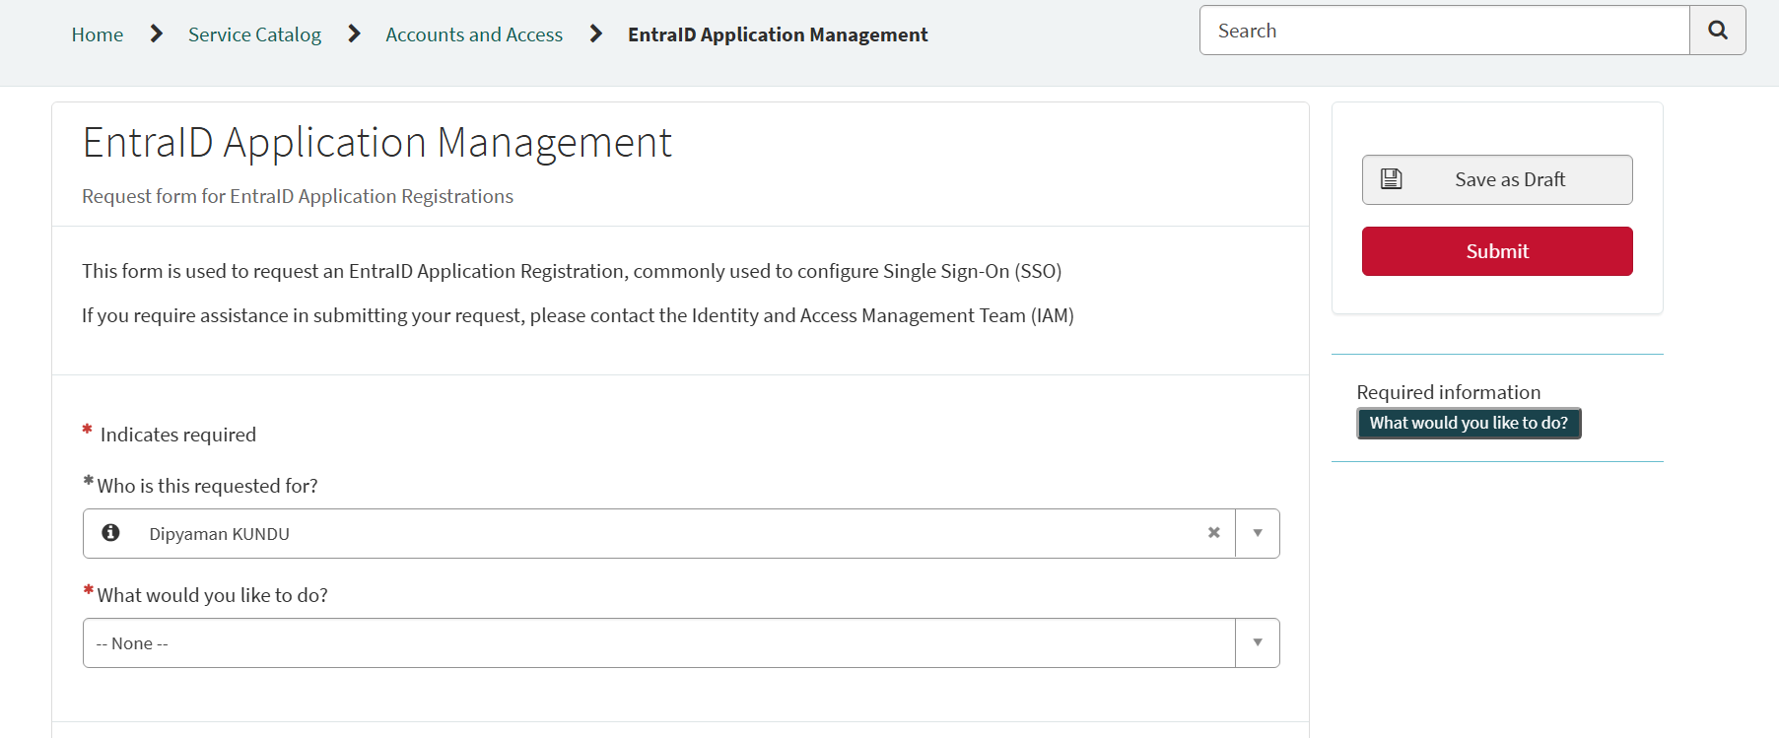

Raised a ticket in serviceNow: RITM1018250

14/10/2026:
- D2-rest:

OTDS | https://documentumintl-np.wde.woodside.com.au/otds-admin | otadmin@otds.admin | svcotdsAdminNP@123

OTDS Configuration

- Creating New Synchronized User Partition
Step 1: AZUSSC1DCS01.wde.woodside.com.au
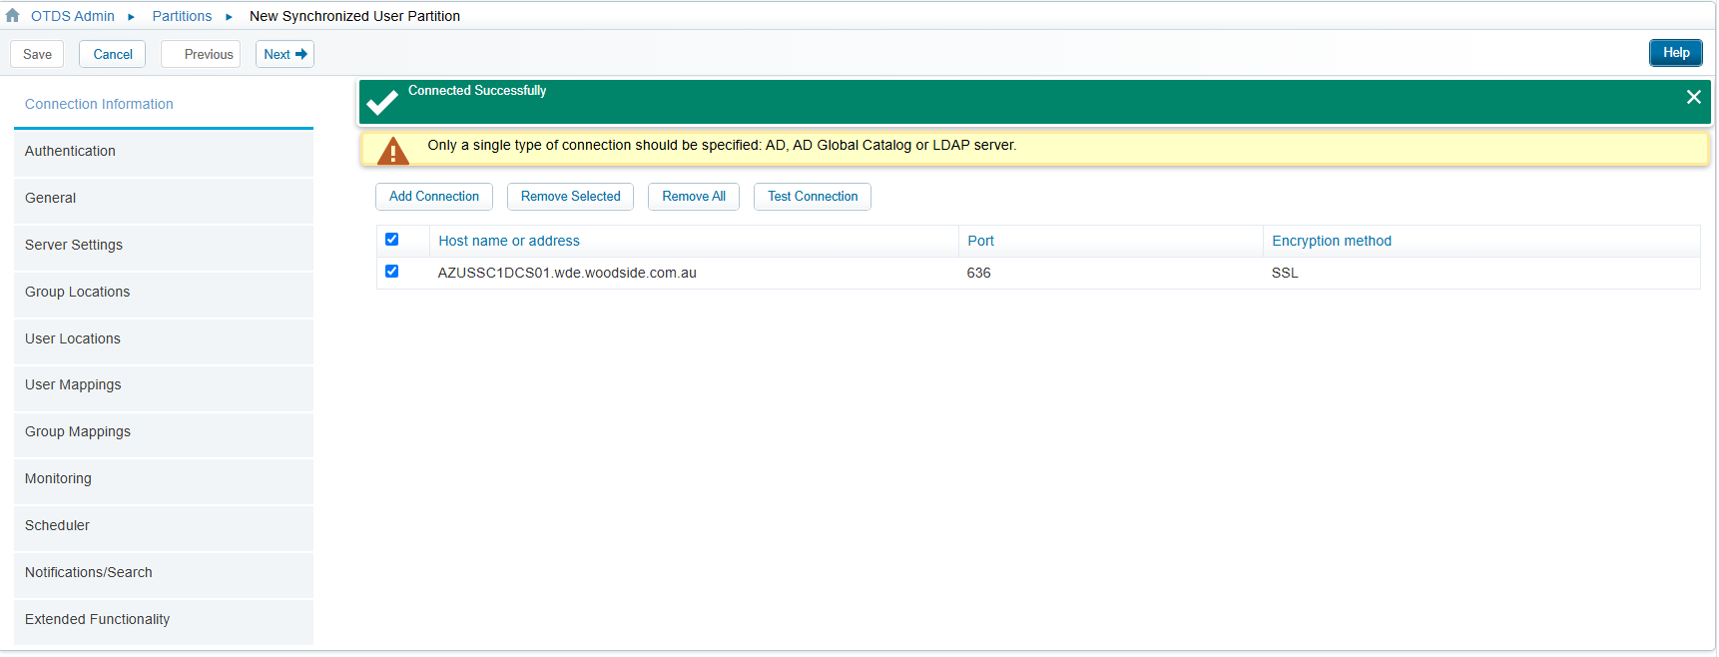
Step 2: Need to raise a Savyent request. Ticket id: RITM1018931
svc.dctm_otds_np
Si}]T<47vGKZnm9]:PlI'\~gzvdk!%
